The Current Economic Dilemma: Past, Present & the future
Tay Jingyi
[16/8/2010]

[Type the abstract of the document here. The abstract is typically a short summary of the contents of the document. Type the abstract of the document here. The abstract is typically a short summary of the contents of the document.]

Author’s note
I started writing this essay somewhere around July 27 2010. I wrote this essay intermittently for weeks after that day. A polytechnic graduate with an Accountancy diploma, the thought process needed for economics always excites me. I wrote this essay hopefully to demonstrate my prowess in the area of economics and I humbly beg for your forgiveness for any errors spotted. While it is physically and mentally tiring writing this essay, I felt it was worth it all as I realized how interconnected we are and how things are despite the living in cities so far apart.
Initially, I wanted just to touch briefly on the sub-prime crisis before moving on to talk about stocks I view favorably. But I realized that there was no way for me to talk about stocks without going through the fundamentals; the economy and the global markets. Economics is interesting as in reality, it encompasses not only theoretical formulas and theories but also take into account people’s behaviors, beliefs etc; how each nations acts like an entity itself with its own foible habits and behaviors.
Hence, I started digging deep into this economic situation and have never looked back since. It is fascinating how the crisis is concerned with so many different factors from deflation to unemployment to global trade and taxes etc. Some of the ideas being brought forward here have already been presented on the internet whereas some was thought up by me. Thus, I hope readers would get a better idea of everything related to the current economic crisis in coherent with the world’s economy and delve into the topics which inspires them the most; this essay can be thought of as a compilation of ideas as compared to internet articles which emphasizes a lot on inflation/deflation, debts, double-dip etc, which are important but never the less too hyped up.
Hopefully my essay encourages readers to dig deeper to gain insight on the rest of the issues which needs to be addressed; by looking into historical events, how other countries operate economically and how it is important for the everyone in America, corporations alike, to step up and hover through this crisis.
Lastly, I pray that the war on terrorism ends soon.

Views on the current U.S economy as compared with Japan’s
With the future trend of the U.S economy uncertain; unemployment still high; the weird situation of low inflation along with low interest rates; many of us wonders where the economy will be heading this time round as compared to previous crisis like the great depression or the Japan deflation era. Well, hopefully this thesis provides the readers with sufficient clues and evidences to complete the puzzle and perhaps form a bigger one out of this whole mess. A brief history on this recent crisis will be touched on, then delving into topics like inflation and deflation; the state of the economies of other nations and how we could reflect that on America’s situation; ideas that can be implemented to increase inflation and how to curb one of the most important indicator of this crisis: unemployment rate.
Inflation may not increase anytime soon and not at a high rate due low demand in goods. I did also like to note Mr. Ron Paul’s comment to Mr. Ben Bernanke’s decision to deal with the situation at hand. By inflating the currency, subsequently causing the rise in prices of products, what if unemployment still does not decrease but instead increase? And since lowering interest rate to near zero, inflation has not risen high enough to overcome the recession. Thus deflation may occur if Americans do not help themselves by consuming more goods even though interest rate is low. Hopefully the situation does not continue into one like Japan’s, though I would think it is unlikely as every nation has its own psychological and cultural differences.
For Japan, even with interest rates lowered to near 0%, inflation did not occur due to the dwindling asset prices at the early stages to the decrease in local and international consumption. The thriftiness in particular with Japanese did not help to spur economic growth; thriftiness has become a cultural habit and is passed on to the current generation, making it hard for Japan to help itself out of its own economic turmoil. It would be highly unlikely to see America fall to the depths of Japan considering how the two societies differ in terms of consumer spending and habits.
Japan’s high current account surpluses reflect the extreme fiscal policy put in place by the government to make exports one of the main pillars of the Japanese economy. Even though the scheme is successful, with Japanese companies dominating global industries, the net claims of Japanese institutions on foreigners – the loans being made and the factories, buildings, and companies that they own abroad- far exceed those of any other country, all these wealth never directly translate into the wealth of its citizens but instead goes to the pockets of the wealthy individuals and major corporations, with the government translating the dollar profit into yen to finance capital that the exporters need rather than consumer spending, thus compressing consumer spending, preventing inflation to occur. This policy does not strengthen the yen but in fact weaken the yen against the dollar as Japan uses the dollar as its trade currency, the yen does not exchange hands and circulate globally when international trade takes place but instead gets stuck within the domestic market. [2]
If you refer to the 2010 Japan data, unemployment rate is at 5.3% as of June 2010 with a mean of 4.68% over a 10-year period compared to the 7.9% unemployment rate with a mean of 5.74% that America has. So, although deflation does play a certain part in increasing the rate of unemployment, the major issue here currently for America is NOT inflation or deflation but unemployment rate; how to decrease unemployment rate before deciding on the direction of the economy.
As the graphs show, Japan’s inflation rate for the past 10 years had mostly been negative which expects to continue due to its government policy. From 2004 to 2008, unemployment rate decreased steadily however Japan’s inflation rate fluctuates negatively with a few positive spikes of slight inflation; with the spike between 2006 to 2007 attributed to strong economic growth. The economic growth seemed to affect Japan’s unemployment rate as it eventually hovered around 4% with a slight dip although it did not last due to the economic uncertainty prior to the global crisis during 2008. Since then, unemployment rate has been hovering around 4.6 peaking at 5.6.
Similar graphs of United States’ unemployment rates and inflation rates are shown below, revealing not much change in relation to both rates except for the period of year 2008 and beyond. With the inflation rate attributable towards oil, food and core inflation
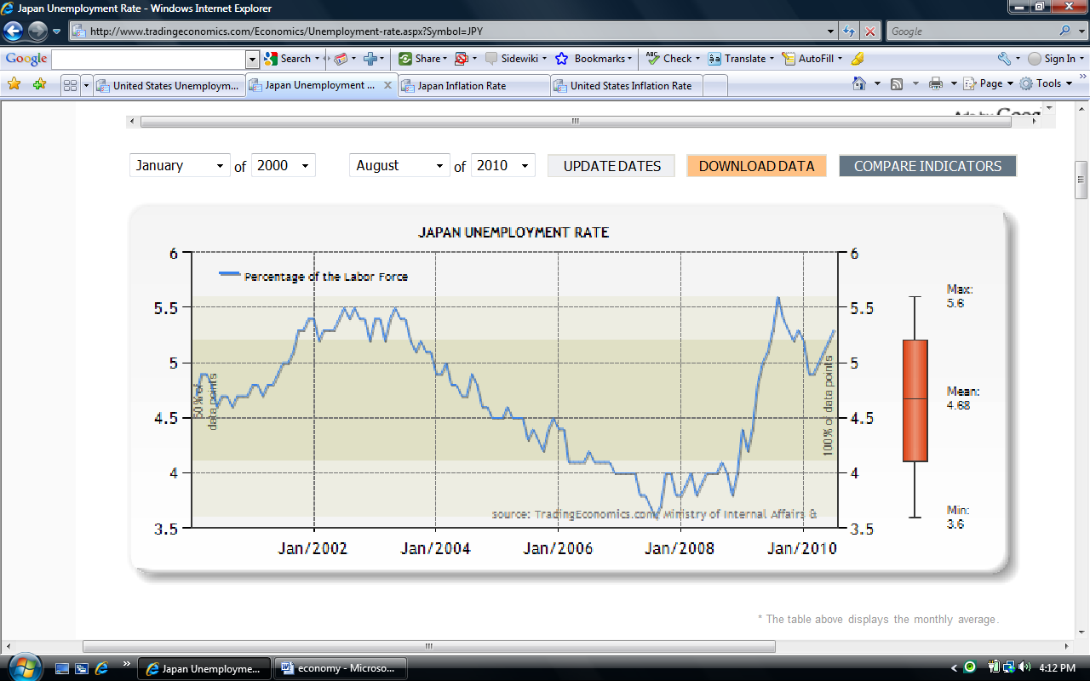
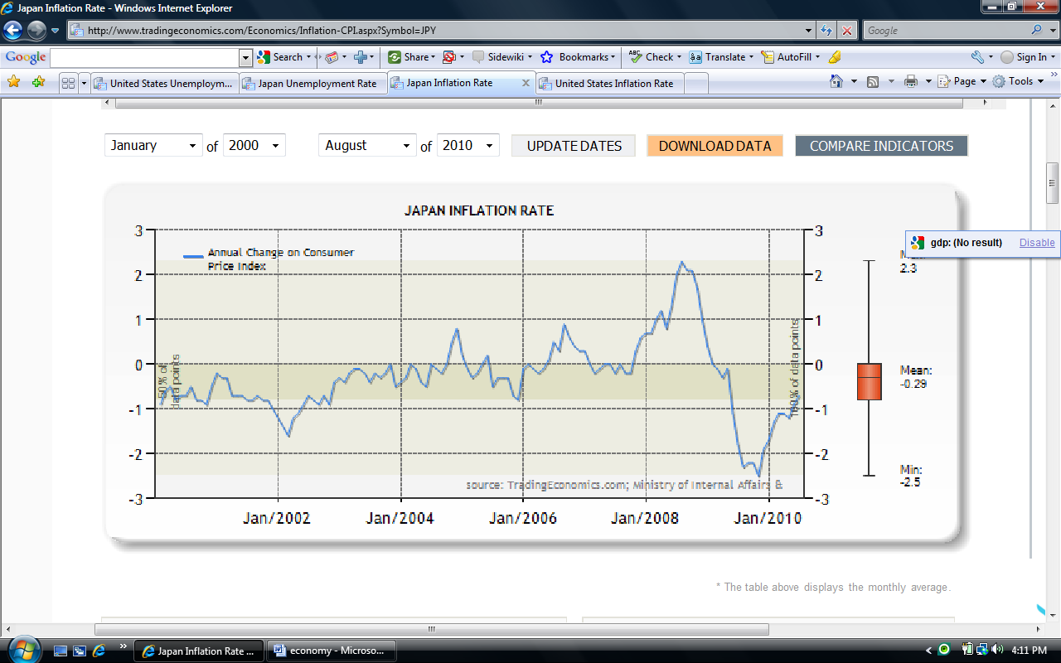
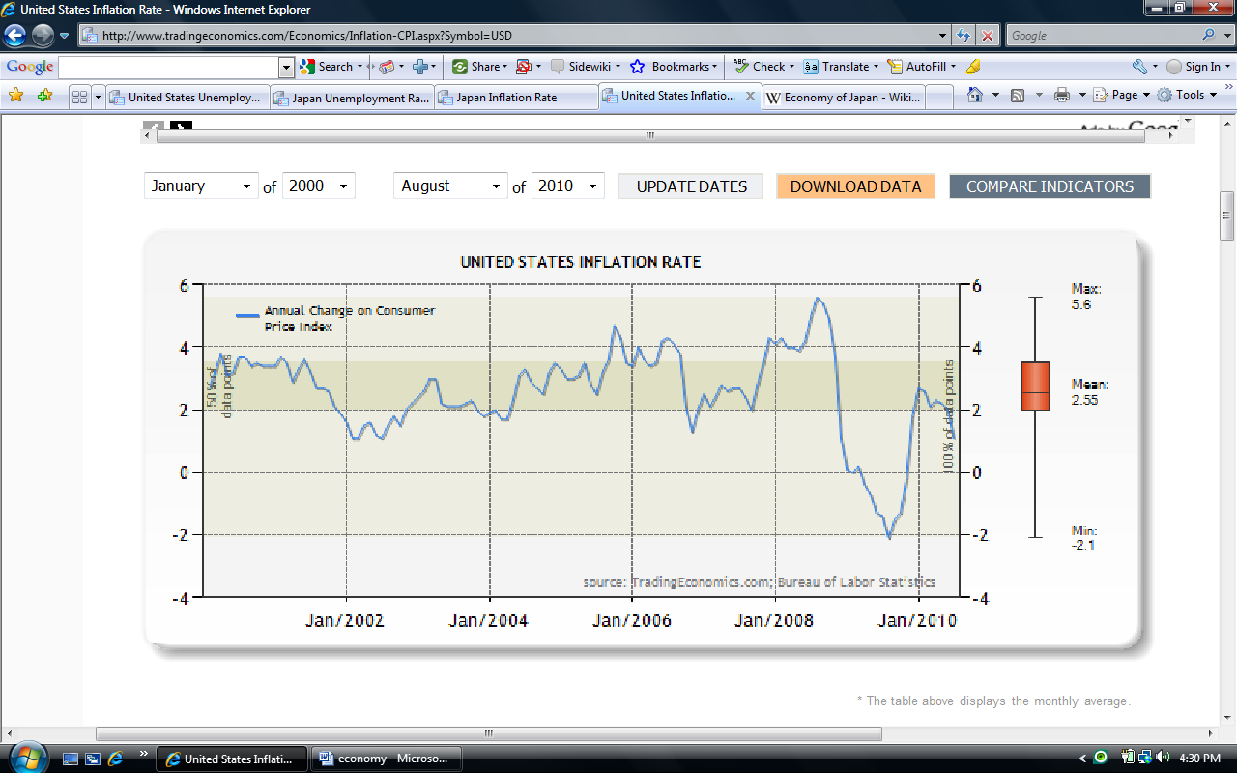
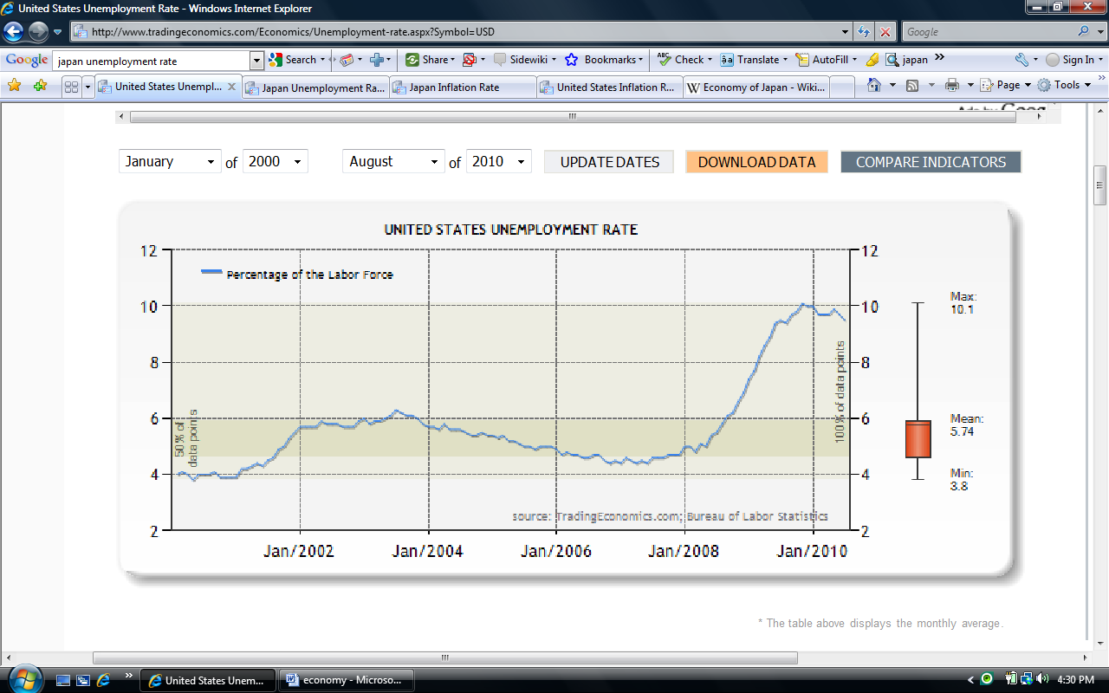
Brief view on Britain’s economic situation
For Britain, a strange effect occurs such that inflation grew to 3% spurred by growth of 0.3%. Suspected reasons were mainly the high inflation rate consumers thought would last for a while; increase in companies prices due to lack of supply caused by bankrupted competitors and concern of cash flow caused by unwillingness of banks to lend. Again I believe the difference between Britain and the rest of the nations may be their psychological thinking towards the prospect of spending and the economic downturn. Thus even though Britain might still be laden by huge debts; America may consider Britain as a candidate to change positions with, periodically. [1]
Conclusion
Therefore by taking the facts from these relevant countries to America’s viewpoint, it does not make sense for America to fall into deflation particularly when consumer spending is on the rise, its low inflation should not encourage deflation hawks and instead there should be a optimistic viewpoint for Americans to look up to so higher GDP can be sustained and not fall into a situation like Japan. It is the psychological and cultural impact that led Japan into being trapped in a economic abyss, since America is not a “Saver’s nation” in the first place, such situation could hardly happen unless the 1930s incident happen again, which would be unlikely considering that the fed has opened up its reserves and swift action was taken to bail out the major financial institutions.
The statements above should soothe the sentiments of people and companies of America alike and by encouraging companies with political and economical certainty so companies will start investing in America and start hiring Americans to ease the unemployment rate in the nation.
Furthermore, the government’s policy differs from Japan, being less aggressive on exports, America can depend on itself for survival; and having panoply of world-beating industries and companies will not hurt at all, as they continue to produce products spurred by global demand.
Part 2: job creation and implementation of fiscal policies
It is also important that Americans know that the government will not save them from being bankrupt time and again by engaging in more credit. Therefore public sentiment, most importantly, those of the major corporations should be soothed in order for investments to take place to spur the economy once more. Interest rates and deflation should not be scrutinized; unemployment rate being the main importance; and the government should aid the country’s export while increase investments locally. Below are graphs taken from Paul Krugman’s blog, illustrating government consumption and investment spending for hiring workers, building roads etc in contrast to government unemployment insurance benefits. There is a noticeable increase in insurance benefits compared to the gradual increase government consumption in creating more jobs. However the government should not be blamed as they saved us from getting into a similar situation like the Great Depression by swiftly taking actions, given that more than $3 trillion has been spent on this crisis has been justifiable; consequences could have been a lot worse if no actions were taken. With more than $13 trillion total federal debt and all that’s done by the government, domestic corporations should step up and start doing their part for the economy by beginning to hire workers instead of sitting on the side-lines waiting for the storm to clear with piles of cash sitting beneath them.
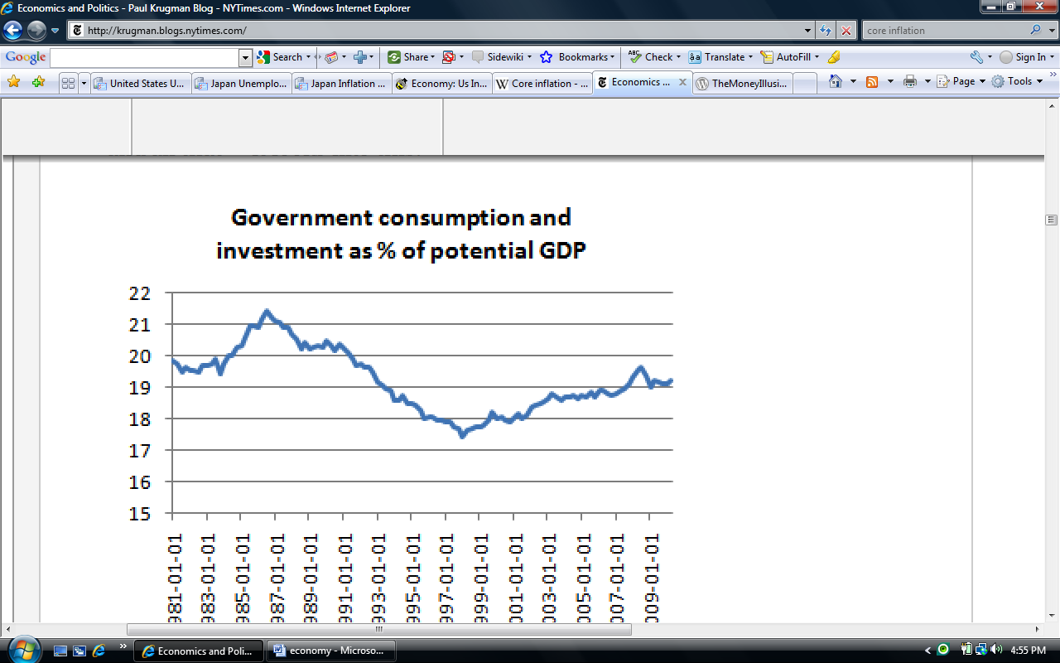
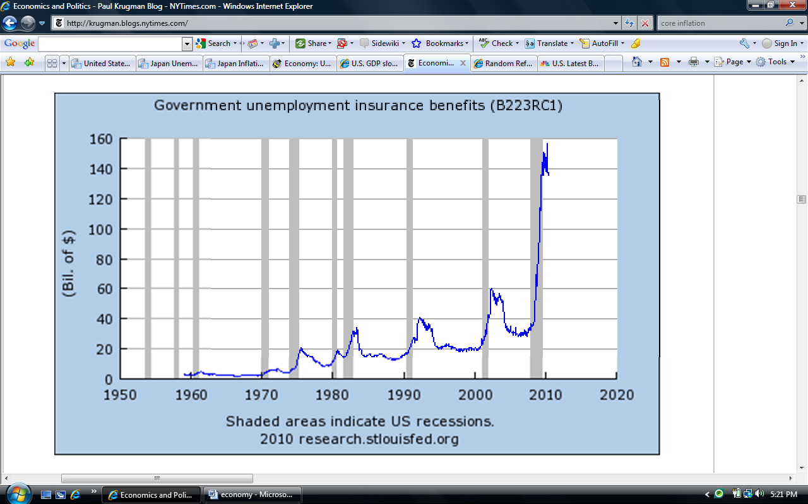
Deflation may not seem pretty but it may benefit the consumers more since products are cheaper. Furthermore, for the short-term economic situation at hand, deflation might prove beneficial at hand for Americans at large since unemployment does not decrease at an efficient rate anytime soon and growth does not increase fast enough to stimulate the economy. Hence, unemployed people and families will not suffer so much with lower consumer prices, considering companies reporting profits for year 2010 yet hold record $837 billion in cash with no intention of investing and hiring workers due to the economical and political uncertainty. However deflation would prove devastating to people with debt.
And perhaps short-term increase in taxes for the upper class and employees in the financial industry would be justifiable as part of the problem was from the financial industry and upper class people with high income could help out the middle class and the poor citizens of America. My sentiments are supported by Obama’s decision to cut tax breaks for household income earning more than $250,000 a year. I not only strongly support this decision but also think that the idea of the reform of the tax system in America would be beneficial for America as a whole.
Statistics show that an annual income of $250,000 or more represents the top three per cent of American households; more than four times the national medium. However, I believe that earning $250,000 does not represent that you are rich but only perhaps belonging in the upper middle class range. As a Singaporean, I can relate to the people who live in places like Manhattan where property prices are sky high, especially during this period where the economy here is experiencing high growth and inflation. Further statistics show that between 2002-2007 bottom 99% of the incomes only grew 1.3% a year in real terms compared to the 10% growth that the top 1% had, whereas the top 0.1% seen their share of national income triple over the same period. The top 1% also accounts for two-thirds of all income growth in those years. All these statistics reflect the unfair distribution of income growth across all levels, the rich churns more cash into their pockets while the others, the people facing minimal wage increase, had to slog harder to catch up with the increase in expected production during the period of healthy economic growth.
Therefore, it makes much sense to introduce a better tax system by adding more tax brackets targeting the specific high-income individuals who are far off from the rest of the league. By that I mean the wealthy individuals who earn millions a year; directors of major corporations, bankers, movie stars etc. These individuals who earn millions but are taxed at the maximum bracket of $375,000, does not add up. These are the people who should be contributing more back to the economy and the country especially during this critical period. At least by adding more tax brackets will allow them to feel the pinch that the middle class and the lower class felt, and, by increasing the tax brackets, we can allow everyone to contribute more to the economy.

A time of deflation may also be better for the recovery of America’s economy as local corporations may find employment to be cheaper in America; raw materials needed to make products cheaper; thus able to produce more and supply more of its products globally and rapid expansion can be made with the Dollar weakening against other currencies. This move is similar to countries like Japan and China where trade current account surplus has been a major factor in their economies. The difference between the two countries is that China is not adamant for trade surpluses to take place by investing the surpluses back into investments in fixed assets; fuelling domestic demand for goods. Thus America can take advantage of China’s demand of goods, whether its consumer or industrial goods, to maintain a balance in America’s economy; major corporations like Macdonald’s(food industry) or Ford (automobile industry) can expand aggressively into China and satisfy China’s domestic demand for goods or, in this case, imported goods. Therefore it represents the time for America to chalk up its trade surplus that has been suppressed over the years.
Increase investment in America to cope with inflation/deflation
The US government should provide more incentives for more Foreign Direct Investments in America as to facilitate employment growths. Measures that could be done: increasing tax tariffs and import duties on goods to combat the weak currencies, providing tax rebates and provisions for every worker hired. Even though the products will ultimately be served to American customers, the comforting part is that the products are made in America by Americans and sold to Americans; payroll is given to Americans to increase employment thus decreasing our trade deficits given the fact that the actual production occurs on home soil. Such measures should also be given to domestic companies so their products could be sold at a lower cost to fend of competing products which are imported. In the worse case scenario, if demand does not increase or prices keep dropping, control of prices should be done accordingly.
[2] Let’s look at the interesting situation Japan has, as a result of maintaining its trade surplus. Japan opens FESA to prevent inflation by keeping US Dollars, but since too much US Dollars has been kept in there, Japan in turn transfers them to US bonds, securities, and assets. The upside is the increase demand for their goods, downside being deflation as production capacity exceeds domestic and global consumption for Japanese goods and with US Dollar not being converted into Yen to prevent the yen from being used by consumer spending and strengthen against the US $ to hinder exports, Japan instead suffers from deflation. However this time, this method of sustaining the economy of Japan may not work; especially with America’s currency weakening, the yen would inadvertently strengthen against it. With America its own meddling problems to handle, it may be time for Japan to find a solution to their economy from within, and not rely too much on its exports. This is the time to compromise and not aim for the budget surplus. Citizens of Japan should be getting higher amounts of disposable income to spur consumer spending. Citizens of Japan should have the right to buy imported goods which may be more expensive than domestic good, instead of channeling the money back to the government through taxes. Income earned abroad by big corporations should not just stay abroad but be brought back to Japan to be shared with the employees who deserved them. Amidst this economic uncertainty, this would be the time for Japan to reconsider and re-evaluate their stand on their monetary and fiscal policy, to try and test options during this period would benefit Japan in the long run as the opportunity cost will be greater as the global economy becomes more prosperous. Only then will Japan truly prosper at last. With that, international trade would be more prosperous, benefitting America as well.
Although the weakening US currency may show signs that it could not be the once dominant currency of the global economy, such worries should be put aside until economic growth and targets have been achieved. It also might show a reversal of trend as Asia gets to be more self-sufficient as exports level have almost reached their pre-crisis peak despite the sluggish economy of US and Europe. This represents an opportunity for US to increase their exports as the global or Asia economies are being fueled by countries like China and India.
By keeping domestic currency at bay, currency does not strengthen compared to other currencies, thus demand would be more favorable towards the weaker currency. Investments overseas allow companies overseas to use domestic capital goods thus decrease excess products. America can learn from Japan by investing in companies overseas then supplying them with domestic goods for their production process; thus increasing productions which will inadvertently increasing employment. An example will be the manufacturing of high technology goods where different stages of production may need to be done in different countries due to the shortage of skilled workers in some developing countries.
By increasing the portion of US Dollar being retained overseas, US Dollar will weaken against other currencies; hopefully, foreign investments will increase. By predicting increase in domestic spending and investments, inflation will soon increase and can be adjusted by reducing circulation of US Dollar and increasing competition for goods by loosening the import tax for goods.
Another idea to take opportunity of this distress is to form a government investment corporation as a holding for the sub-prime assets and loans to the banks. The housing assets could be repackaged and developed into prime residential areas to sell them to potential overseas investors. This corporation can also take part in overseas investments so as to increase inter-country reliance, which would be beneficial for America at the moment. Examples of sovereign wealth funds are like Singapore’s GIC, China Investment Corporation (CIC) & Abu Dhabi Investment Council (ADIC).
Lure wealthy immigrants into the country who would be likely to invest in the country. Methods that can be used are reduction in inheritance taxes, investment taxes and mortgages for the first few houses being bought. Good examples would be like Dubai and Singapore, where lucrative houses are built surrounded by spectacular sceneries to lure the wealthiest to invest in their country. During the period of developing the estates, economies could expect reasonable growth.
Prevention of similar crisis in the distant future
An important factor to ensure the continuous safety of the economy, if, the crisis subsides is the increase and maintenance of US household savings rate. A minimum savings rate should be imposed so citizens at least have a safety net to rely on during uncertain times like these. Also, a minimum savings rate ensure credibility of people making home loans as it makes common sense to only pay what you can afford. Loans are best made with adequate documentations and down payment to ensure subsequent payments are made consistently. As we are entrenched in an economic crisis, people supposedly save more. However savings of US citizens are insignificant compared to people of other nations like China and Japan. According to survey, only 13 percent of households are currently saving 7 percent or more on their disposable income. Another survey done a few years back shows that more than 40% of woman had less than $500 in their bank; for those between 25 to 34 years old, the percentage without rainy day fund jumped to 55%. [3] [4]
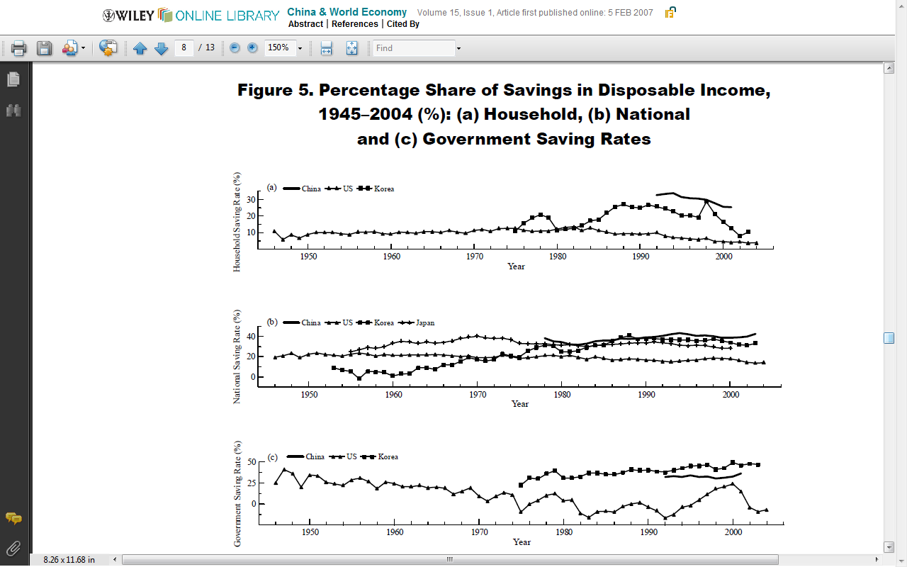
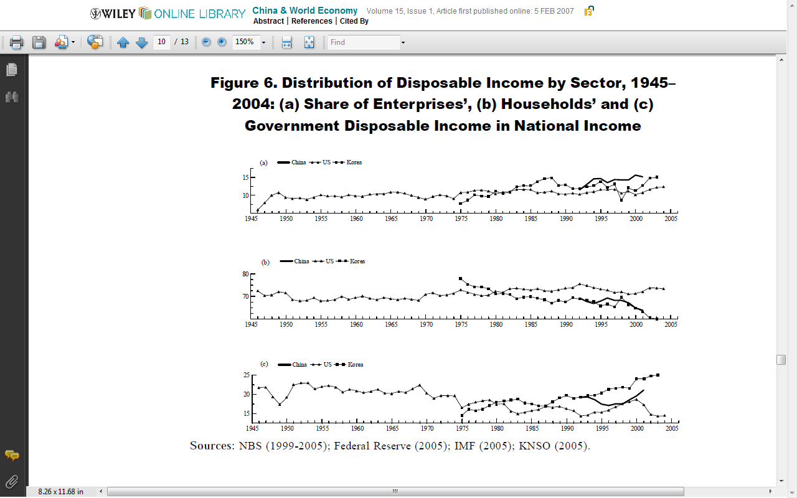
As one can see from the graphs above, China’s savings rate for household, national and government exceeds US’s, despite distribution of disposable income being significantly lower as compared to US’s. From reading the research paper which provided the graphs, I conclude that the adopted view of precautionary saving in China is misleading. Both rural and urban household savings rate rised significantly only after China adopted an open policy in 1978. This could mean that the people saved only when they had higher disposable income at hand. Precautionary saving could be dismissed as during the period of 1978-1984, control on the price of small products was removed; policy on agricultural products was changed, leading to huge increases in rural household income. However, consumption was still low resulting in high savings. The high savings rate remained unchanged despite the high inflation experienced in the late 1980s and the deflationary period of 1997-2000.
This shows that the people ultimately still practice frugality despite increases in income although further research shows that aggregate saving rate of Chinese households apparently declined during the last 10 years; precautionary saving hypothesis does not prove unwavering.
China’s saving rates, despite international criticism, are on the right track as it is coherent with its stage of development. This can be proved by comparing them with Korea’s saving rates- which though are of different time periods but reflects the similar stage of development that China has now. Similar conclusions could be made when compared to Japan’s savings rate. [5]
What remains uncertain is whether China is able to sustain its 16% household savings rate for the decades to come, to avoid a dilemma similar to US’s. Hopefully when the economy recovers and interest rates are on the raise again, more people would make use of this fact and continue to increase their savings.
Lastly with the war against terrorism still waging on, costs are over $500billion and mounting, with no ways to recoup losses unless US snatches away the massive oil reserves in these middle-east countries, this seems to be a losing battle. Decisions must ultimately be made by Mr. Obama for what’s best for America and the world.
Conclusion
Therefore by taking the facts from these relevant countries to America’s viewpoint, it does not make sense for America to fall into deflation particularly when consumer spending is on the rise, its low inflation should not encourage deflation hawks and instead there should be a optimistic viewpoint for Americans to look up to so higher GDP can be sustained and not fall into a situation like Japan. It is the psychological and cultural impact that led Japan into being trapped in a economic abyss, since America is not a “Saver’s nation” in the first place, such situation could hardly happen unless the 1930s incident happen again, which would be unlikely considering that the fed has opened up its reserves and swift action was taken to bail out the major financial institutions. In anticipation of deflation, price floors could be temporarily implemented to deter consumers from predicting the decrease in prices.
The statements above should soothe the sentiments of people and companies of America alike and by encouraging companies with political and economical certainty so companies will start investing in America and start hiring Americans to ease the unemployment rate in the nation.
Furthermore, the government’s policy differs from Japan, being less aggressive on exports, America can depend on itself for survival; and having panoply of world-beating industries and companies will not hurt at all, as they continue to produce products spurred by global demand.
With Mr. Obama who negotiated tax cuts on America’s export into China and expected visit to South Korea for Free Trade Agreement, it seems America is on the right track to increase trade surplus which in return would provide more jobs domestically. It would be time for America to rely on its bilateral relations with developing and developed nations to increase its exports like how Japan and China did in order to facilitate further economic growth. Nations around the world should also be educated at how rapidly the rate of change the global economy is currently undergoing. Good relations should be fostered and maintained and one should not be too persistent on its own policies in terms of trade, fiscal and monetary.
Ultimately, an important lesson could be learnt from this crisis: Prudency. Throughout history, banks seem to have been part of the factor which causes the economic crisis which happened. Much more could be done to regulate the banks and much more could be done to educate people about the importance of savings and not buying what they cannot afford.
From what Mr. Obama has done and will continue doing so, hopes should be kept high that the Fed will keep the economy going with jobs being added; citizens and corporations alike should rally behind their nation to tide over this crisis. Let’s also hope that the war will end soon without further draining our resources.

[1]Britain’s inflation Pain Poses risk for recovery. Julia Werdigier. Published July 6, 2010 http://www.nytimes.com/2010/07/07/business/global/07pound.html
[2]Japan’s policy trap: dollars, deflation, and the crisis of Japanese finance. Akio Mikuni & R. Taggart Murphy. Brookings Institution Press, c2002.
Japan’s culture of not spending crimps economy rebound. Takehiyo Kambayashi. Published 12, 2009. Retrieved from http://www.csmonitor.com/World/Asia-Pacific/2009/0412/p16s01-woap.html
Future of the fed. Frederic Mishkin & Mark Olsen. August 3, 2010. Retrieved from http://www.cnbc.com/id/15840232?video=1558242914&play=1
Random Refereeing: How uncertainty hinders economic growth. Richard Fisher. Retrieved from http://dallasfed.org/news/speeches/fisher/2010/fs100729.cfm
Chadwick: are we facing inflation or deflation. Published 3 Aug 2010. Patricia Chadwick. Retrieved from http://www.cnbc.com/id/38540183/
Behind the Fed’s Policy leak. Published 3 Aug 2010. Larry Kudlow. Retrieved from http://www.cnbc.com/id/38544148/
Frederick Sheehan. (August 13, 2010) The ‘Flations. Message posted to http://www.aucontrarian.blogspot.com/
Weak dollar fuels China’s buying spree of U.S. Firms. Ariana Eunjung Cha. January 28, 2008. Retrieved from http://www.washingtonpost.com/wp-dyn/content/article/2008/01/27/AR2008012702380.html
American Made.. Chinese owned. Sheridan Prasso. May 7, 2010. Retrieved from http://money.cnn.com/2010/05/06/news/international/china_america.fortune/index.htm
Made in America by China: New Turbine Factory Offers Glimpse into the Future. Stacy Feldman. Nov 18, 2009. Retrieved from http://solveclimate.com/blog/20091118/made-america-china-new-turbine-factory-offers-glimpse-future
U.S. economy improving, more stimulus isn’t the answer, Rubin, O’neill say. Courtney Schlisserman and Shobhana Chandra. Aug 9, 2010. Retrieved from http://www.bloomberg.com/news/2010-08-07/u-s-economy-improving-more-stimulus-isn-t-the-answer-rubin-o-neill-say.html
[3] Soak the very, very rich. James Surowiecki. Aug 16, 2010. Retrieved from http://www.newyorker.com/talk/financial/2010/08/16/100816ta_talk_surowiecki
Who is buying Asia’s exports? Frederic Neumann. May 6, 2010. Retrieved from http://www.straitstimes.com/SME+Spotlight/This+week+with+HSBC/Story/STIStory_523266.html
[4] U.S. Savings rate falls to zero. Christian Science Monitor. Retrieved from http://articles.moneycentral.msn.com/Investing/Extra/USSavingsRateFallsToZero.aspx
[5] Understanding High Saving Rate in China (2007). Xinhua He & Yongfu Cao. Retrieved from http://onlinelibrary.wiley.com/doi/10.1111/j.1749-124X.2007.00049.x/pdf
http://en.wikipedia.org/wiki/Price_floor
http://www.themoneyillusion.com/
www.tradingeconomics.com
http://www.brillig.com/debt_clock/

